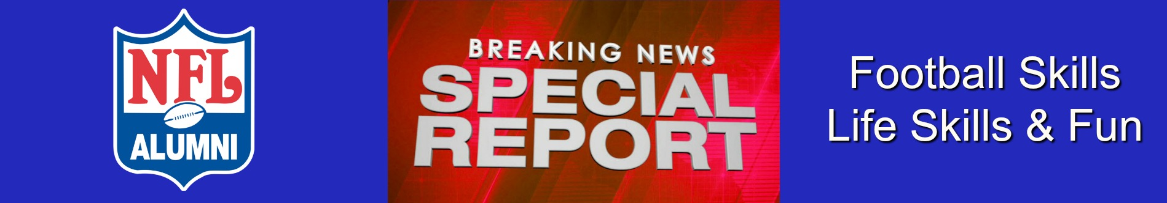
Your Child’s Name Joins Philadelphia
NFL Alumni Youth Football Camp!
----------------------------------------------------------------------------------------------------------------------------------------------------------------------------
Bright Future Ahead for Top Prospect and Great Kid  Philadelphia NFL Alumni Coaches, Heroes and staff are celebrating tonight as one of the town’s biggest stars, YOUR CHILD’S NAME, will join us at camp.  “This is big news! The participation of this youngster makes us a much better camp--no question about it. ” said Program Director Mike Gross. “When you love the game and bring energy and excitement to the camp, everyone benefits. Coaches, Heroes and campers believe this is awesome news!”  The ultimate goal for Coaches and Heroes is to make the camp the best week of summer for all that attend.  “We plan improve our skills--that’s for sure,” says Gross, “But it’s got to be fun--and we plan to have a great time on the football field--together as a group.”  CATCH OF THE DAY: “High Point”   |   Positive Reaction to News!    Camp Highlights Ahead
NFL Alumni Heroes & Pro Coaches
Heads Up Football Instruction
Skill Challenges & Small Space Games
Daily Awards, Prizes, Tournament Action
Championship Friday


